ATLAS: THE QUALITY OF LIFE FOR PEOPLE 65+ IN ENSCHEDE.
Indicators:
- Distance to bus stops
- Distance to GP/hospitals
- Distance to nature
- Distance to shops
- Population density
- Building density
- Percentage of green

Coen van den Nouweland
Nazgul Zhengishbekkyzy
Nationale GI-Minor
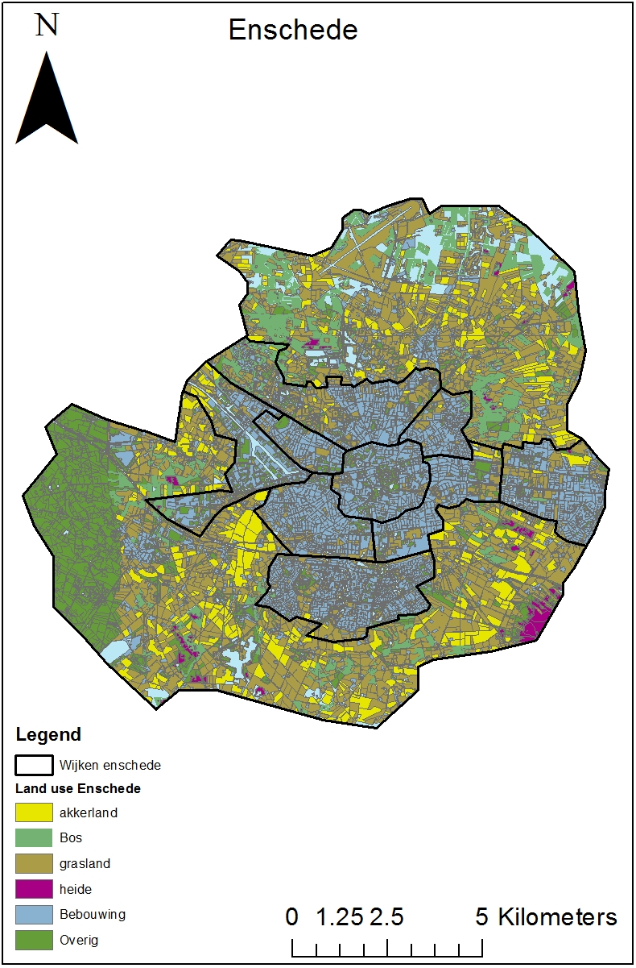
Map 1: Enschede

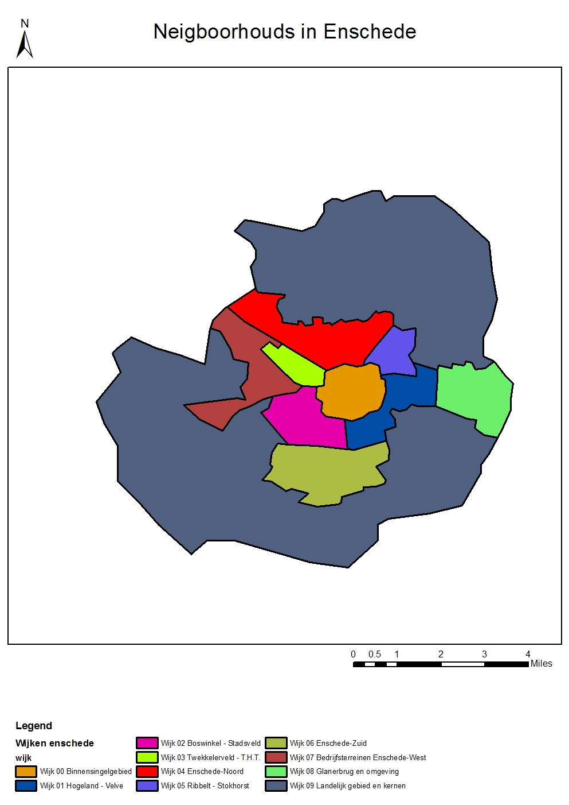

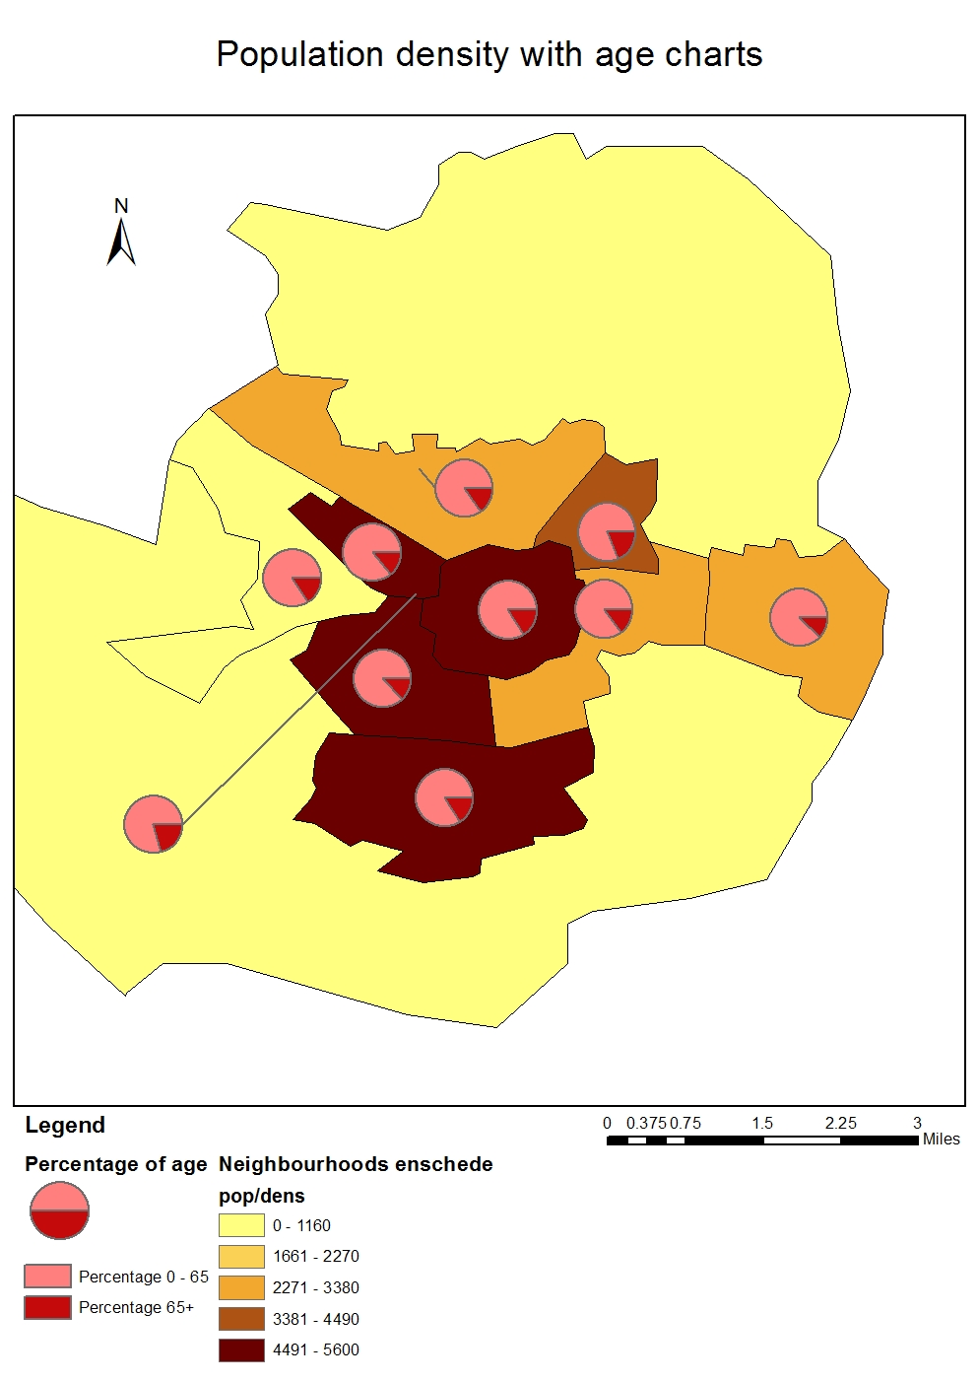

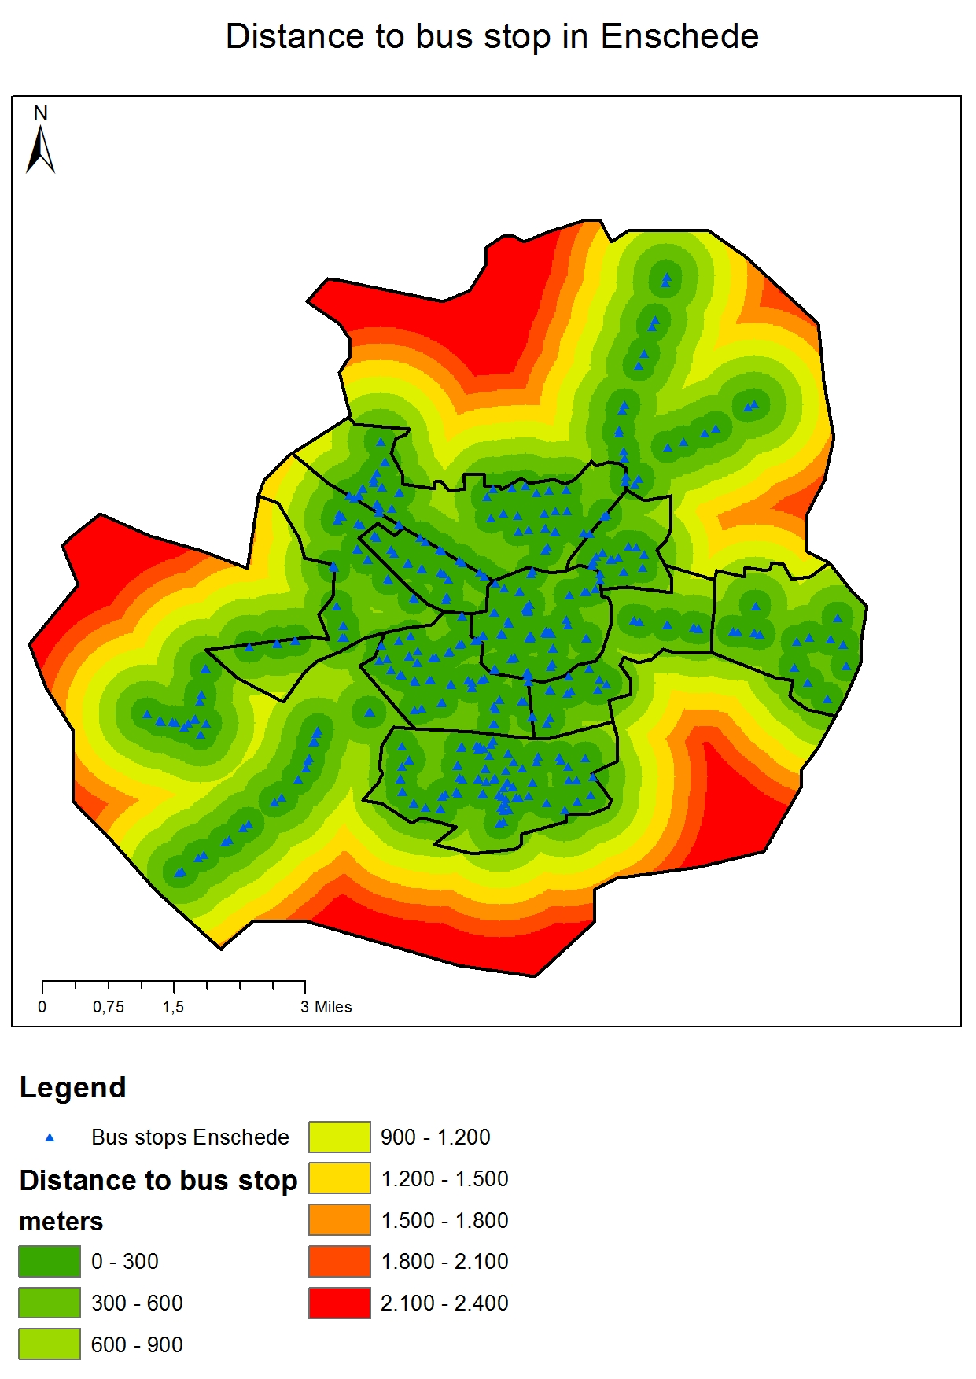
Map 2
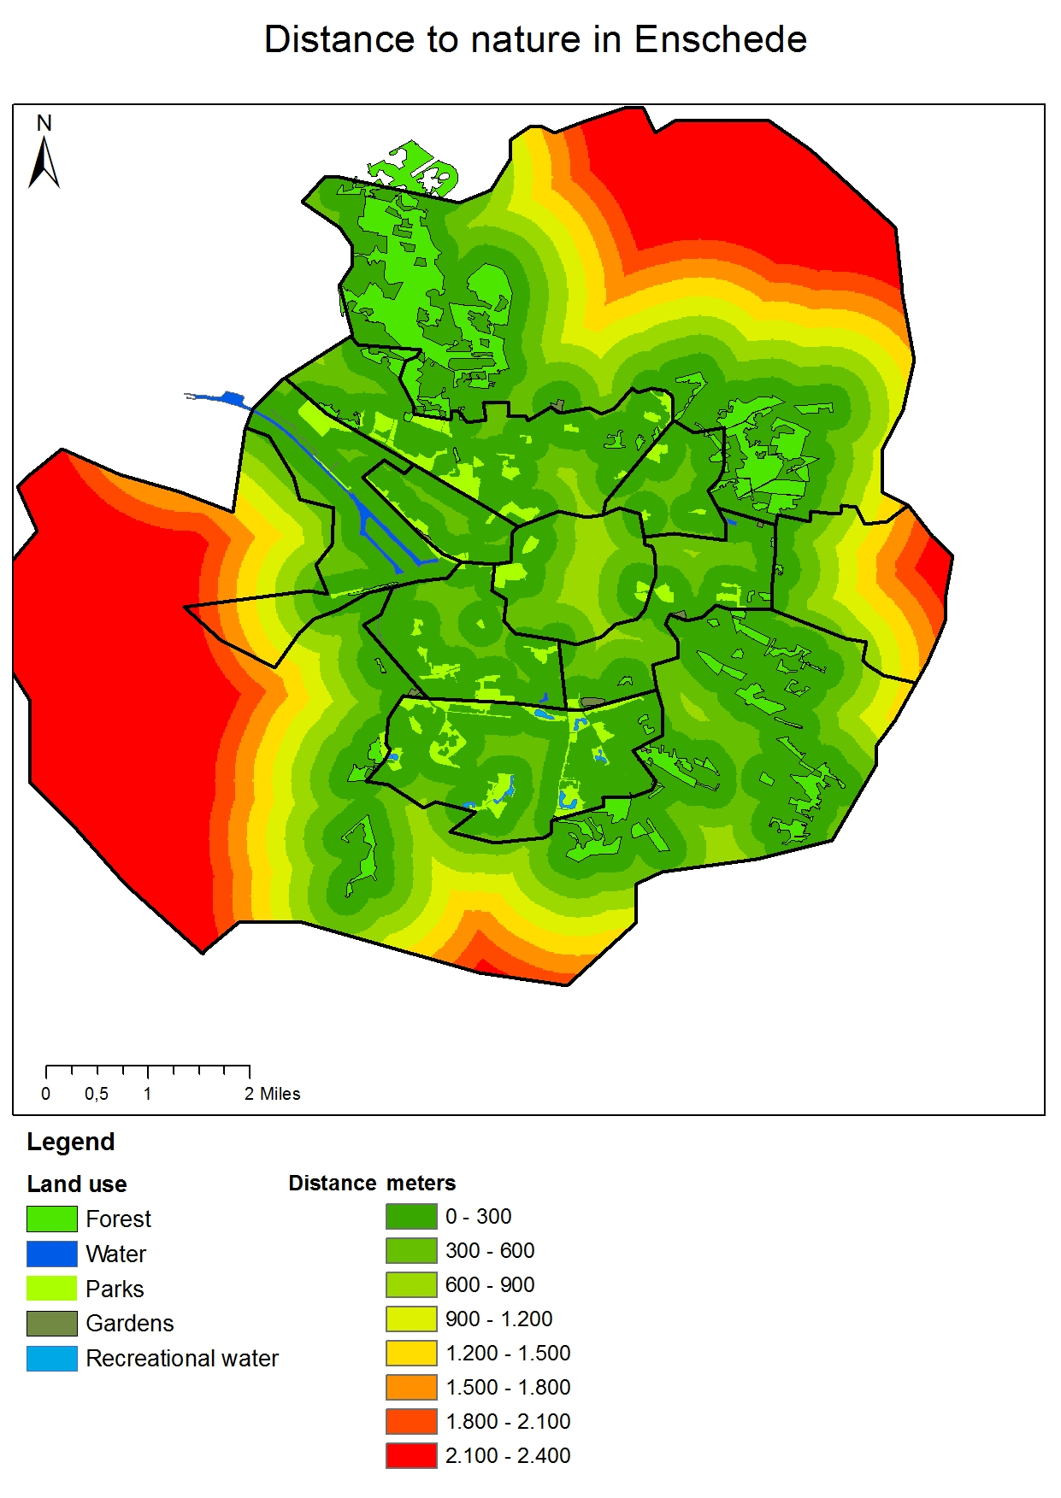
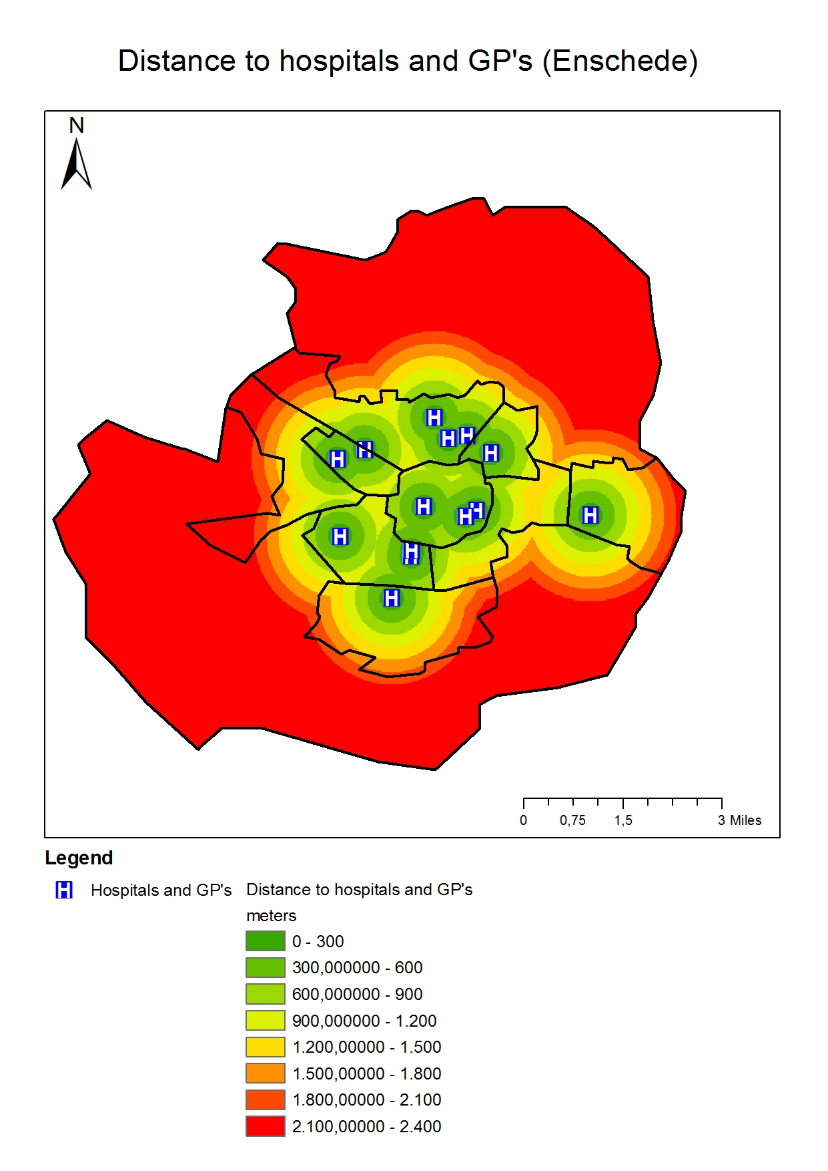
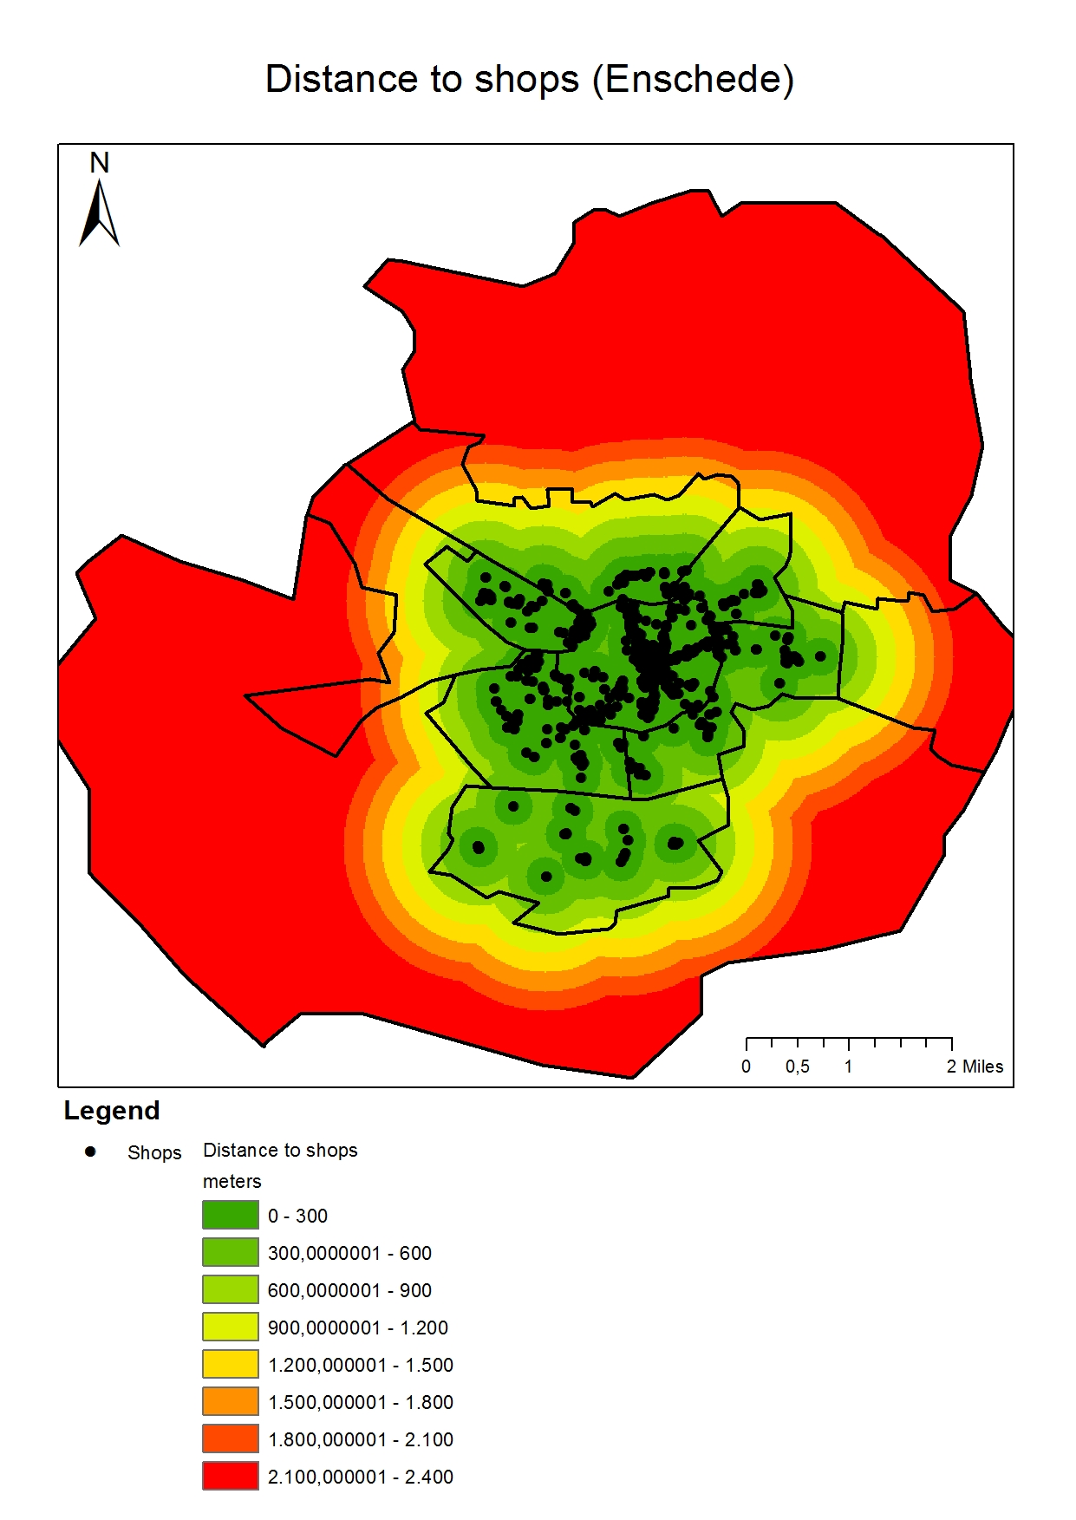
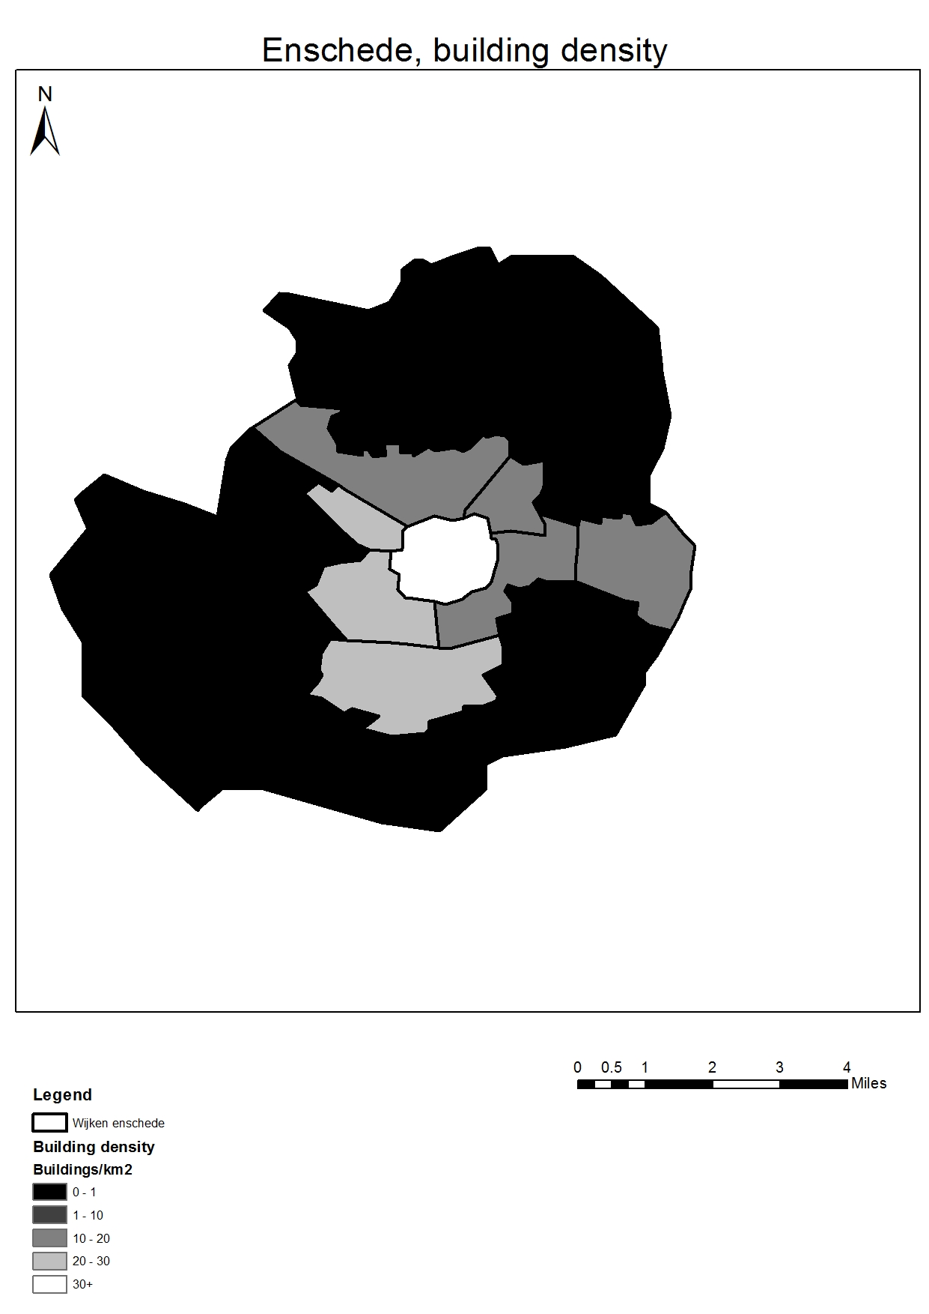
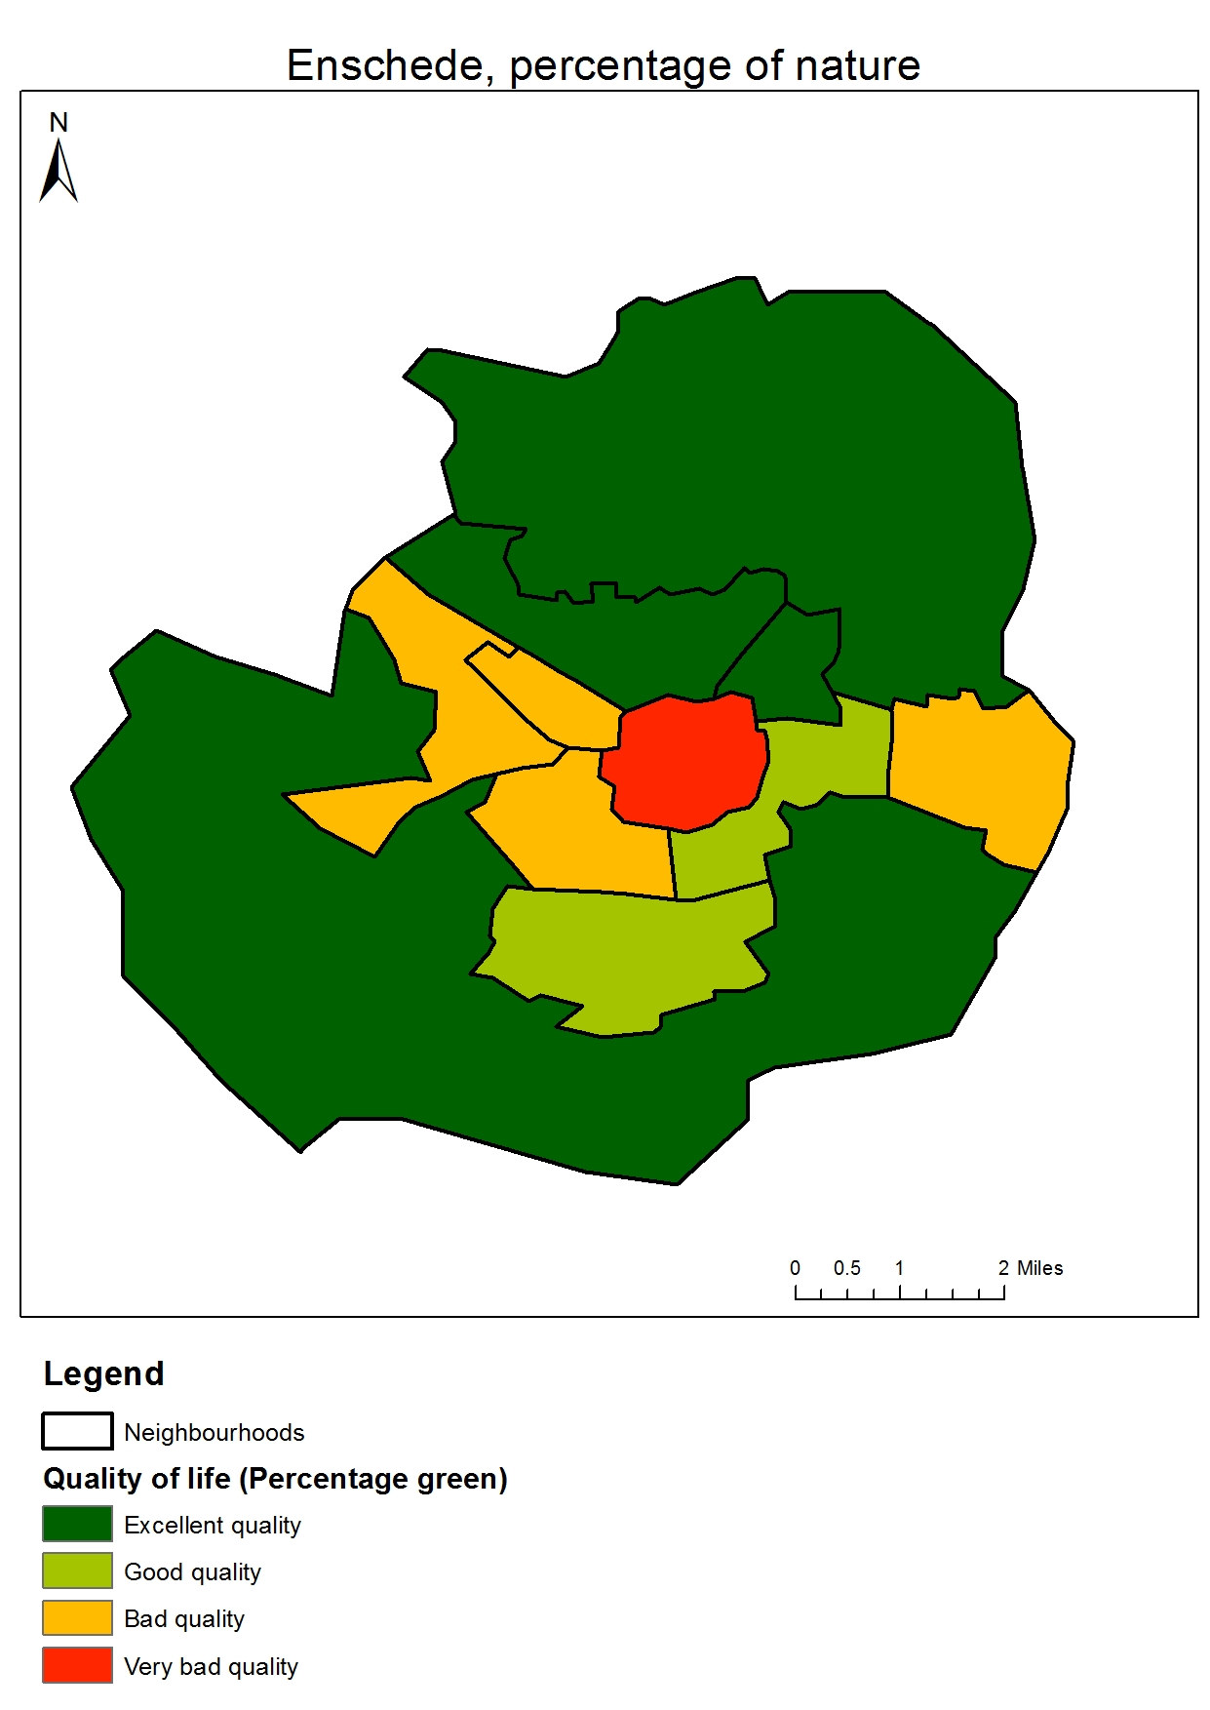
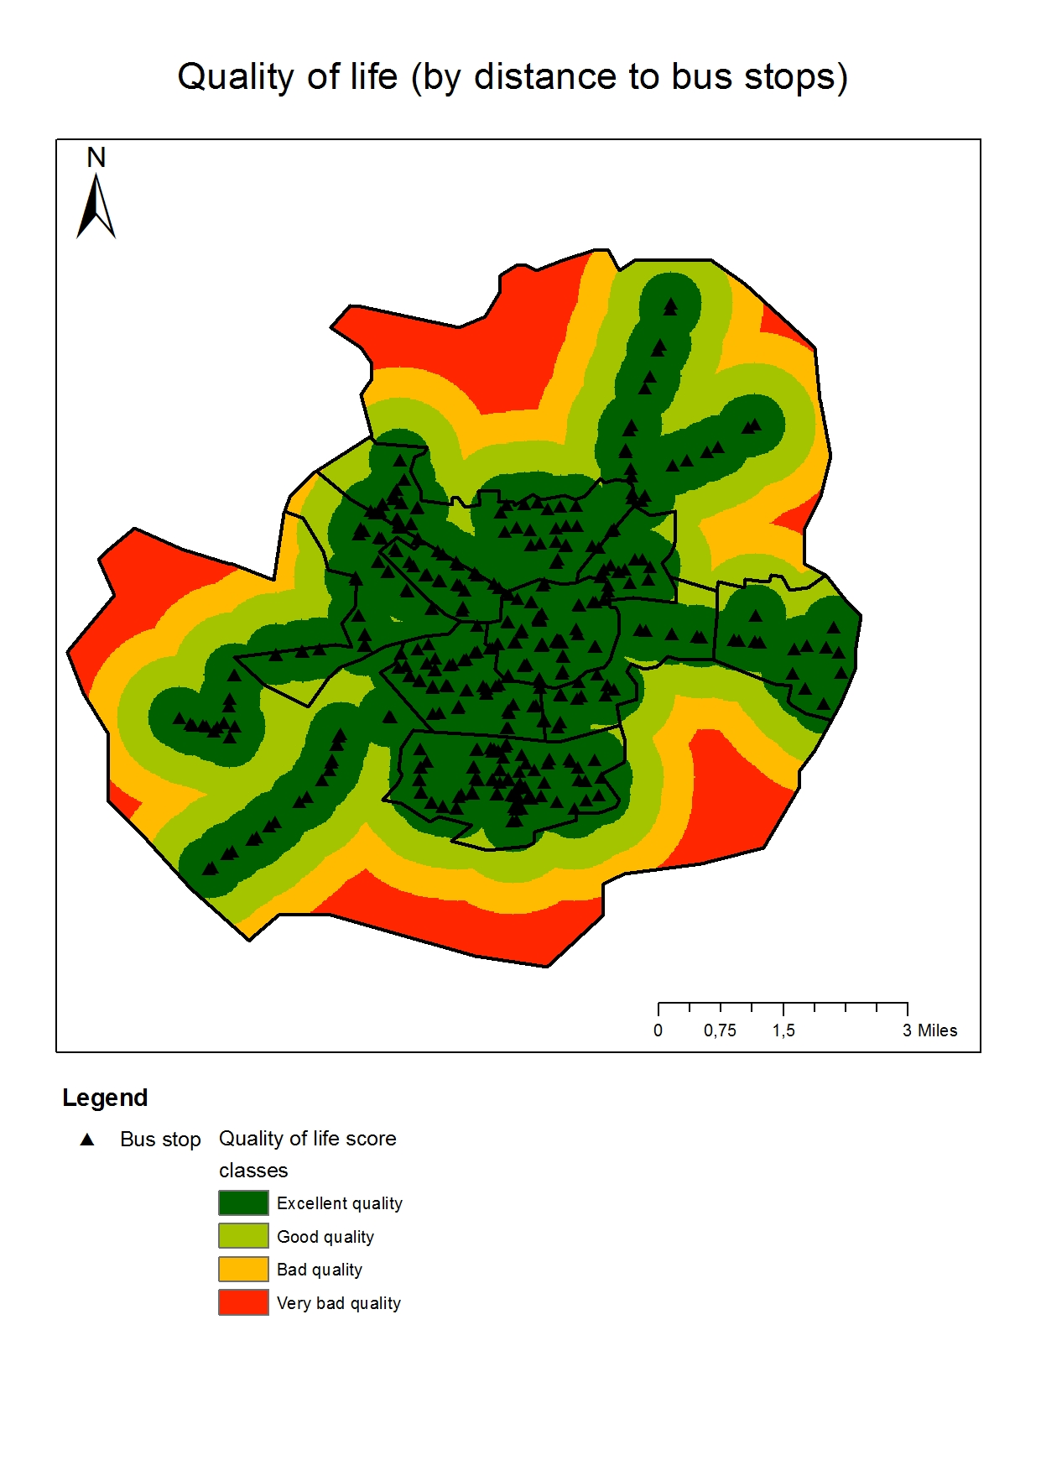
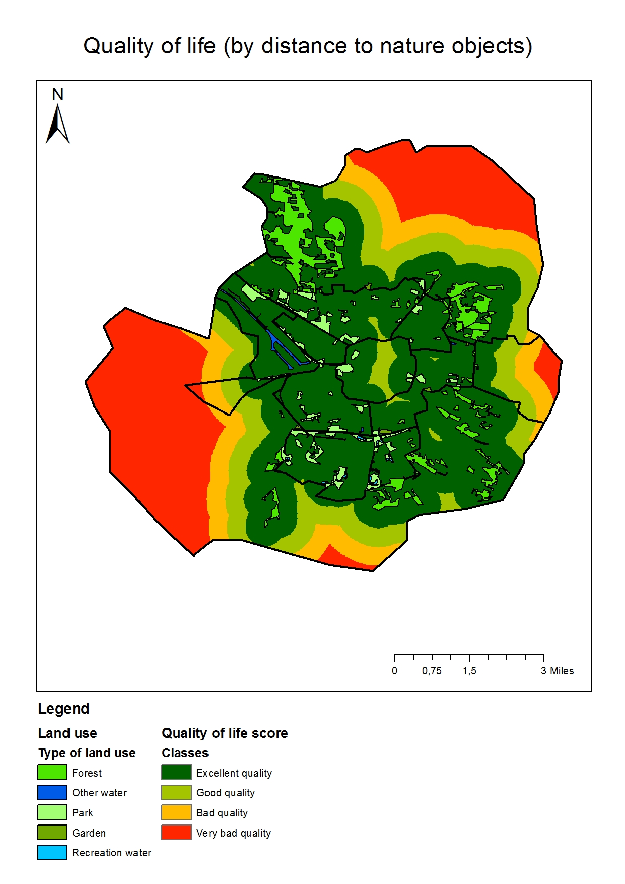
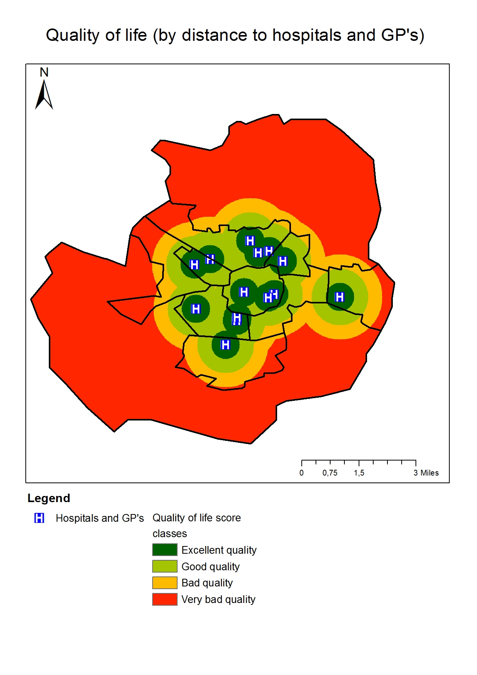
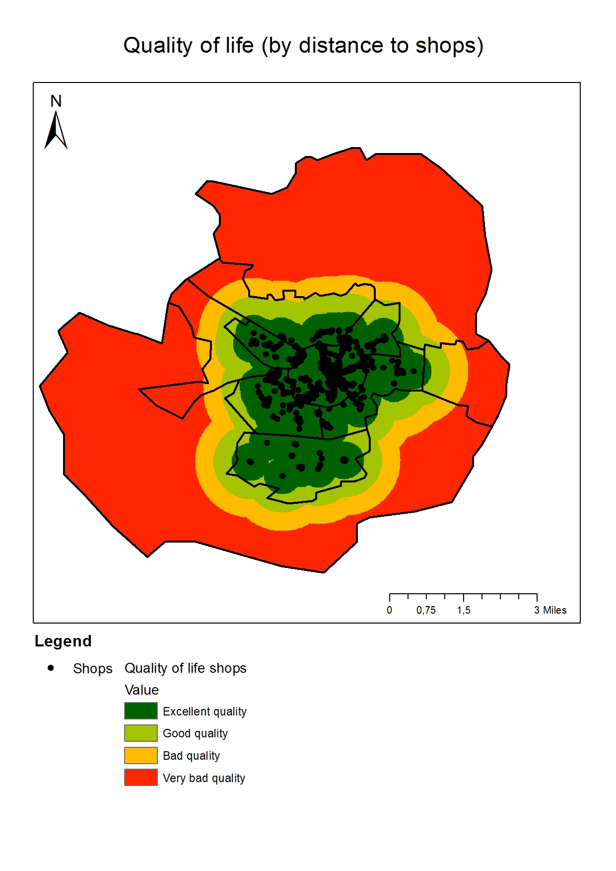
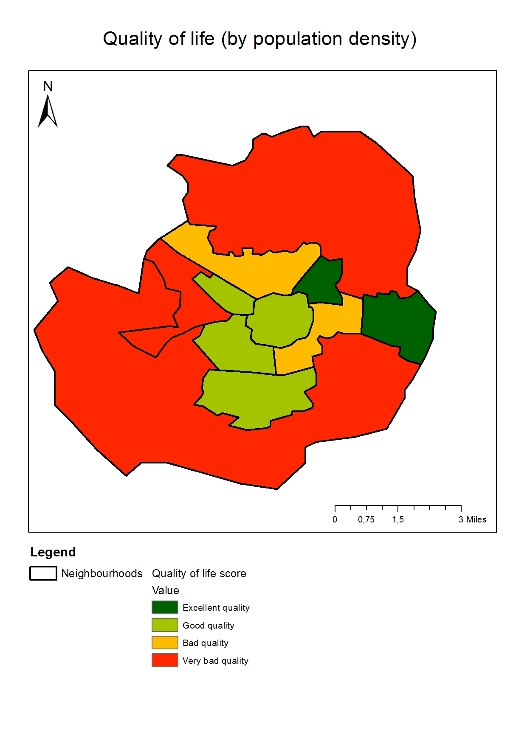
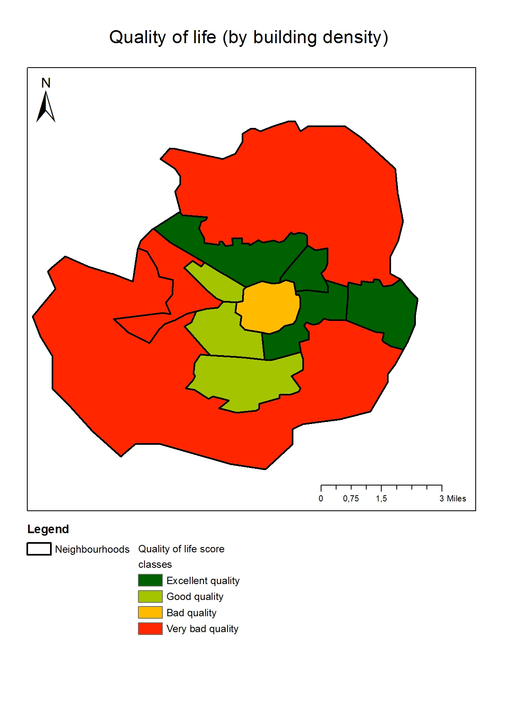
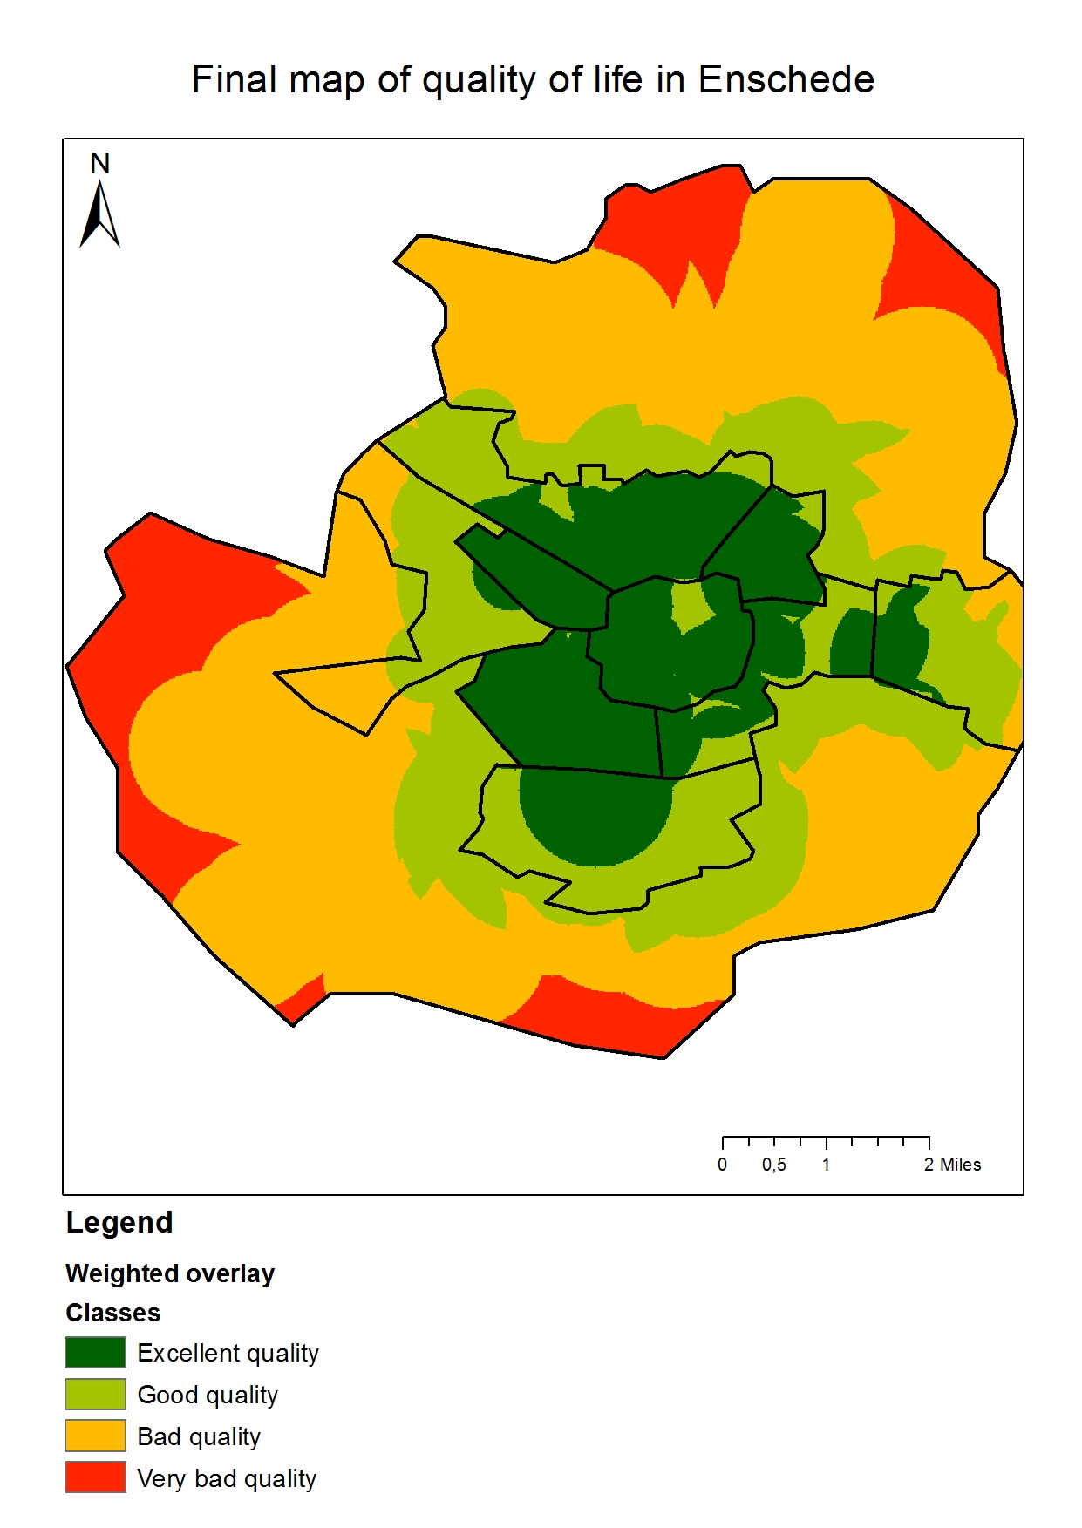
Final map without spot image.
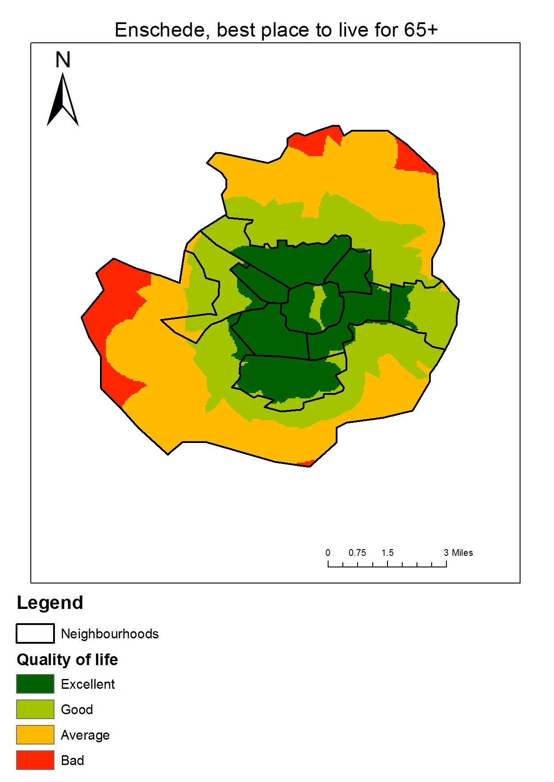
Final map with spot image.
Conclusions:
As a result, we know and can accurately answer the question of where the best place to live for people 65+. You can also see a little ‘gap’ in the center of Enschede. This gap is caused by the lack of nature area’s in that area. The building density is very high in the center and there is less place for parks, gardens or some kind of recreational water areas. This isn’t good for the quality of life.

