PPDAC REPORT: THE QUALITY OF LIFE FOR PEOPLE 65+ IN ENSCHEDE.
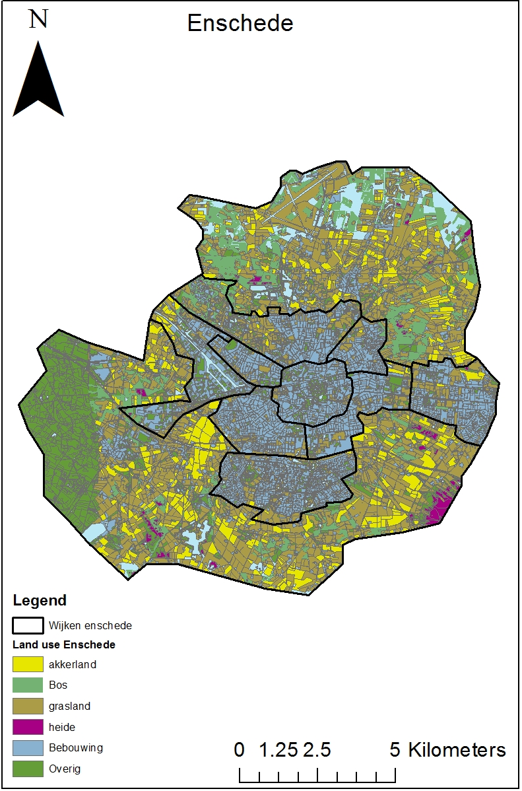

Introduction

The Case study is about livability in Enschede. In this research we explored the quality of life in Enschede especially for people 65+. One of the vulnerable groups of society are old people. And in this assignment we would like to know where the quality of life is best and where is worst. Results of our research will be the map of Enschede which will demonstrate the quality of life for people 65+ by 4 classes from high to low.
In this Case study we will work according to the PPDAC model. This model contains five phases. The first phase starts with describing the problem. After the problem the plan to solve the problem will be described. As third, the data is achieved. When the data is available and achieved, an analysis is made. This is the fourth step. Last of all, we will conclude all our works, results, analysis.

Problem

An important group of people in Enschede is the group of elderly people. As you can see in the figure 1, there are around 25.000 elderly people in Enschede. The total of people who are living in Enschede is around 150.000. This means that 1 out of 6 people has an age of 65 years or older. The number of these people is still rising. The reason for this is the ‘vergrijzing’ in the Netherlands. The number of old people will increase while the number of younger people will decrease. Another reason why this group is important, is the special attention this group demands. Elderly people require a lot more attention than younger people. For example they require more and special healthcare.
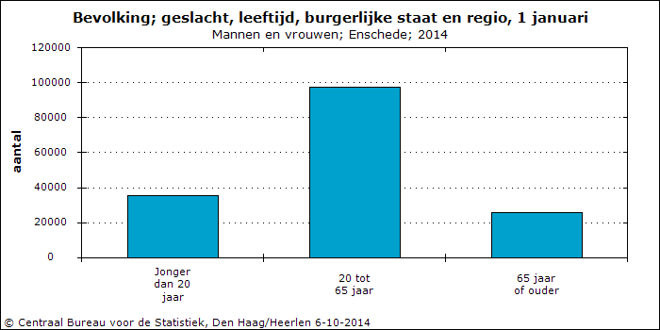
Figure 1
On our excursion to Enschede the guide described there was a large problem with the accessibility in the city. Although this indicator is important for the quality of life, we selected a few more indicators to measure the quality of life. The healthcare and the number of parks, or nature areas for example. Beside the number of GP’s, hospitals, parks and nature areas, the distance from facilities will also be measured because distance is very important for elderly people.

Plan

Our goal was to create a map for the municipality of Enschede. The municipality wanted a map which shows the quality of life in the different neighborhoods in Enschede. After we defined our target group we could focus on selecting indicators and data.
First we selected indicators which are measuring the quality of life. As described above, we selected accessibility, healthcare, nature areas and more.
Elderly people are less flexible then younger people. This means that cycling or driving a car becomes more difficult when you get older. Because you still want to go out when you are old, it is important that there is enough public transport in Enschede. The bus stations shouldn’t be too far away from the living area. Public transport is our first indicator to measure the quality of life in Enschede.
As second indicator we choose public health. Elderly people require a lot more healthcare than younger people and it is important that this healthcare is provided. Because hospitals are very expensive we don’t only measure the distance from the hospital but also the distance from a GP. We’ll also look if these places are accessible by bus. Also we’re looking at the how many GP’s (general practitioner) there are in and around Enschede. We will also measure accessibility to these GP’s.
Our third indicator will be parks and nature. The reason we choose this as the third indicator, is that elderly people are appreciating rest and nature a lot more than younger people. The parks and nature areas should be good accessible in the city. Also there should be enough nature areas for the inhabitants of Enschede.
The next indicator is the distance and number of shops. This indicator also measures the quality of life. A suitable neighborhood to live has different shops, not too far away. This is also an important indicator for the quality of life.
A fifth indicator which we will use is the population density. Together with the number of people who are 65+, we can look which neighborhoods are important in our analysis and which neighborhoods are less important. We will also use this indicator in our final map.
Another indicator is building density. We can measure the building density by dividing the number of buildings over the total area. The building density is also will include in our final weighted overlay.
The last indicator will be the map which shows the percentage of green in the neighborhood. We will use the remote sensing data to create a map which shows the number of green cells in a neighborhood.
In total, we will use seven different indicators. We will use three different approaches to measure the quality of life. The first four indicators will use distance. The fifth and sixth indicators will base on density and the last indicator will base on a percentage of green.
Data: | Indicators | Source:
Distance | Distance to bus stops | ArcGIS online
 | Distance to GP/hospitals | Zorgkaart Nederland
 | Distance to nature | CBS bodemgebruik 2008  (Geoplaza)
 | Distance to shops | Basisregistratie adressen en gebouwen (Geoplaza)
Density | Population density | Centraal bureau statistiek (Statline)
 | Building density | CBS bodemgebruik 2008 (Geoplaza)
Percentage | Percentage of green | Spot Image (Blackboard)

After we defined this seven indicators we will use a weighted overlay tool to measure the final quality of life. This final map shows the quality of life based on seven indicators, each with their own weight. A disadvantage of using this tool is that the weighted overlay tool is very subjective. Each of the indicators must have a weight. This weight defines how much influence the final indicator has in the final formula. The opinions of how big the influence is of an indicator can be very different.

Data
These indicators used for our final result, require a lot of data. We achieved all of the data, by mainly using these websites: ArcGIS online, Geoplaza, Pdok and CBS.
We started with a base map of Enschede. We needed information about roads, buildings, neighborhood borders, green area’s etc. The top10NL layer and the ‘CBS gemeente-, wijk- en buurtgegevens 2009’ layer provided us with this information. With this data we could create a simple map. This simple map shows the basic information of Enschede like roads, buildings, neighborhoods and land use.
We continued with creating a map for our first indicator, the bus stops. This data was available on ArcGIS online. With this data we could easily make a map, showing distance to bus stops.
After creating the first map, we had to find all GP’s and hospitals in Enschede. We found the hospitals by using the Top10NL layer. The GP’s were more difficult to find. We used ‘zorgkaart Nederland’ to find all of the GP’s in Enschede and made our own shapefile of that data. This layer was also vector data.
After we found the data for healthcare in Enschede, we continued with the data for the nature/rest indicator. This layer required a lot of data. We didn’t only measure the distance to parks, but also the distance to forest, gardens and water. All these forms of nature are included in one land use map. We used the ‘CBS bodemgebruik 2008’ layer to find the data for land use in Enschede. With this data we could create a layer, only showing the data we needed.
The fourth distance indicator was shops. We found a map with all shops in Enschede in the BAG layer (Basisregistratie adressen en gebouwen). This map included a layer with ‘verblijfsobjecten_gebruiksdoelen’ which contains data about shops in Enschede. We used that data to create a layer with only point data, showing only the shops.
The density indicators could be easily calculated. First we had to find data about population density. A good source of data was ’Centraal Bureau voor Statistiek statline’ (CBS). Here we achieved a lot of demographic data. We used this source to find the age of different people and the number of inhabitants in each neighborhood. The population density was calculated by the number of inhabitants, divided by the number total land area in a neighborhood. The building density was calculated exactly the same. The number of buildings divided, by the territory of neighborhood.
The last indicator was the percentage of green in a neighborhood. This data was more difficult to find. We used remote sensing data to create a raster map, giving each cell a value. We used an image file in Erdas Imagine to create a reclassified map. This map was imported in GIS and converted to a raster map. The data in this map isn’t very reliable. The error table gave a value of 53% correct values. This value is not very high. With this information we decided to give this map a very low weight in the weighted overlay tool.

Analysis

In this part of the PPDAC model we completed the list of indicators. We’ve used distance indicators (Bus stops, GP’s, Nature and Shops), density indicators (population density and building density) and an indicator based on the percentage of green in a neighborhood. We’ve started the analysis with four vector layers. The bus stops, GP’s, shops and nature areas were all vector layers. We ran a Euclidian distance tool and this gave us four different layers (Cell size: 20). With some clipping and editing we created four maps which you can see in the atlas.
The density maps were made with only one layer. The tables from CBS Statline were joined with a layer of Enschede. With the field calculator in ArcGIS we could easily calculate two types of densities. With data from Statline we could easily add some pie charts to see where our target group lives.
We used the remote sensing data to create a reclassified map with different kind of land uses. The reclassified map was used for the final analysis. We imported this map into GIS and converted it to a raster map. We used some zonal statistics on this map to calculate the ‘green’ cells and the other cells in the raster. With this information we could calculate the percentage of green cells in each neighborhood.
At this point we’ve created seven maps. To prepare those maps for the weighted overlay they need to be reclassified in the same classes. We chose for four classes. ‘Excellent’, ‘Good’, ‘Average’ and ‘Bad’.
The distance maps were easy to reclassify. The closer you live near facilities, the better the quality of life is. We’ve reclassified in steps of 300 meter. If you live between 0 – 600 meter from a bus stop, you’ll live in an area with the value 1. This continues in four classes. Every value above 1200 gets a value of four.
The density maps where a lot harder to reclassify because density is a very subjective issue. One person likes to live in the center of a big city where it is really busy, while others like to live in a small and quiet village where it is really calm. We think that in general, elderly people dislike very busy places, and also don’t want to live all alone because they need people around them to help them. The busy city center with 30+ buildings/Km2 got a value of three and the quiet neighborhoods outside Enschede with a building density of <1 got a value of four. We decided that 1 – 10 per km2 was the best value and gave that the highest grade.
The same values where given to the population density map. The area’s where the population density is very low were graded with a four and the busy city center with a three. The area’s with a population density of 10 – 20 where graded with a two and the more busier area’s where graded with a one. A big disadvantage, mentioned earlier, is that this kind of maps is very subjective. Some elderly people prefer silent areas and others prefer very busy areas.
The last map was the spot image created with remote sensing data. After we’ve reclassified the image we calculated an error table:
Accuracy totals |  |  |  | Accuracy
Class name | Reference | Classified | Number correct | Producer | User
Unclassified | 1 | 1 | 1 | - | -
Rye | 0 | 3 | 0 | - | -
Evergreen | 23 | 22 | 5 | 22% | 23%
Grass | 58 | 56 | 43 | 74% | 77%
Heath | 8 | 1 | 0 | 0% | 0%
Water | 4 | 4 | 0 | 0% | 0%
Maize | 19 | 20 | 14 | 74% | 70%
Grass | 38 | 70 | 38 | 100% | 54%
Dedicious | 22 | 24 | 7 | 32% | 29%
Cereal | 4 | 0 | 0 | - | -
Total | 177 | 201 | 108

Overall Classification Accuracy = 54%
The error tables shows an overall accuracy of 54%. This isn’t really high and questions the reliability of the classified map. While knowing this we continued with our analysis, starting with a reclassification. The ‘green’ cells (cells including nature) were reclassified as 1 and the other cells as NoData. With zonal statistics we could calculate the sum of green cells for each neighborhood and also the area of each neighborhood. With the field calculator we’ve calculated the percentage of green cells in a neighborhood.
This map was a lot easier to reclassify. A high percentage of green received a high value and a low percentage received a low value because more nature is better. We did this with equal intervals and again with four classes.
Now we have seven maps, each divided with four classes. The final step in our analysis was putting these maps in the weighted overlay tool. Again, we have the problem that this tool is very subjective. We had to assign a weight to each map. Some aspect we took into account were reliability of the map, completeness of the data, and subjectivity.
The distance maps are reliable, missing almost no data and are objective. These maps are very useful and we gave these maps a high weight (15-20%). The density maps are also reliable and complete, but a lot more subjective so we gave a lower weight to those maps (10%). Finally, the percentage map. This map was objective, but not very reliable and not complete. We decided that this map isn’t very useful for our analysis and gave it the lowest weight (5%).
We summarized every step in a model. The first image shows the Euclidian distance tools. The second map shows all the tools used for the SPOT image and the third image shows the final weighted overlay tool.
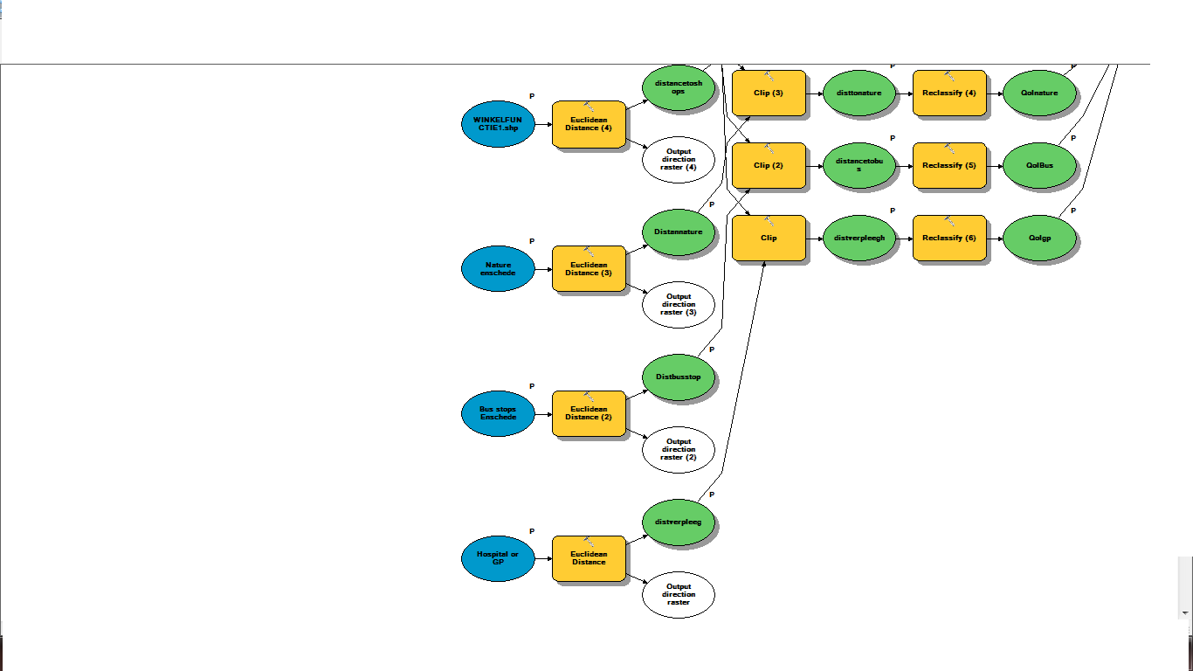
Model 1: The Euclidian distance tools

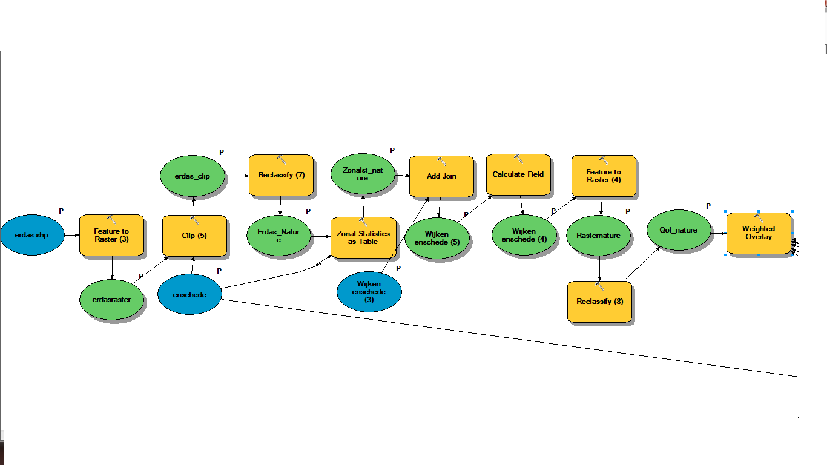
Model 2: The SPOT image
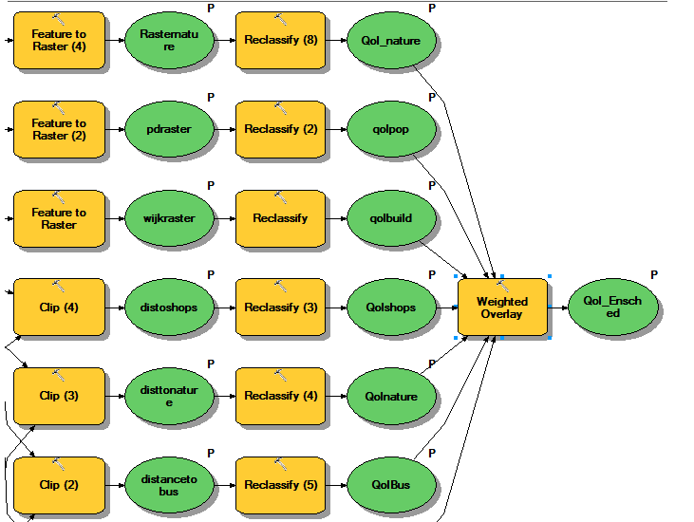
Model 3: The final tools

Conclusion

After we’ve completed the analysis, we’ve created a final map for the municipality of Enschede. This map gives an overview of the quality of life of each 20m² in Enschede. Our final conclusion is that older people will have a better quality of life if they will live in the center of Enschede. This is caused by (the distance to) facilities like shops, hospitals/GP’s, nature and public transport.
As a result, we know and can accurately answer the question of where the best place to live for people 65+. We create our final map for Enschede’s people, because they are wanted to know the quality of life in their city. We think that our case study will be useful for Enschede’s administration to thinking about how to improve the quality of life throughout the city not only in the center. Enschede is necessary to develop all neighborhoods in the city. Improving the quality of life for each district, and groups of society.
We have two final maps, because first one we made without spot image and second one with spot image, so that the results differ slightly from first map.
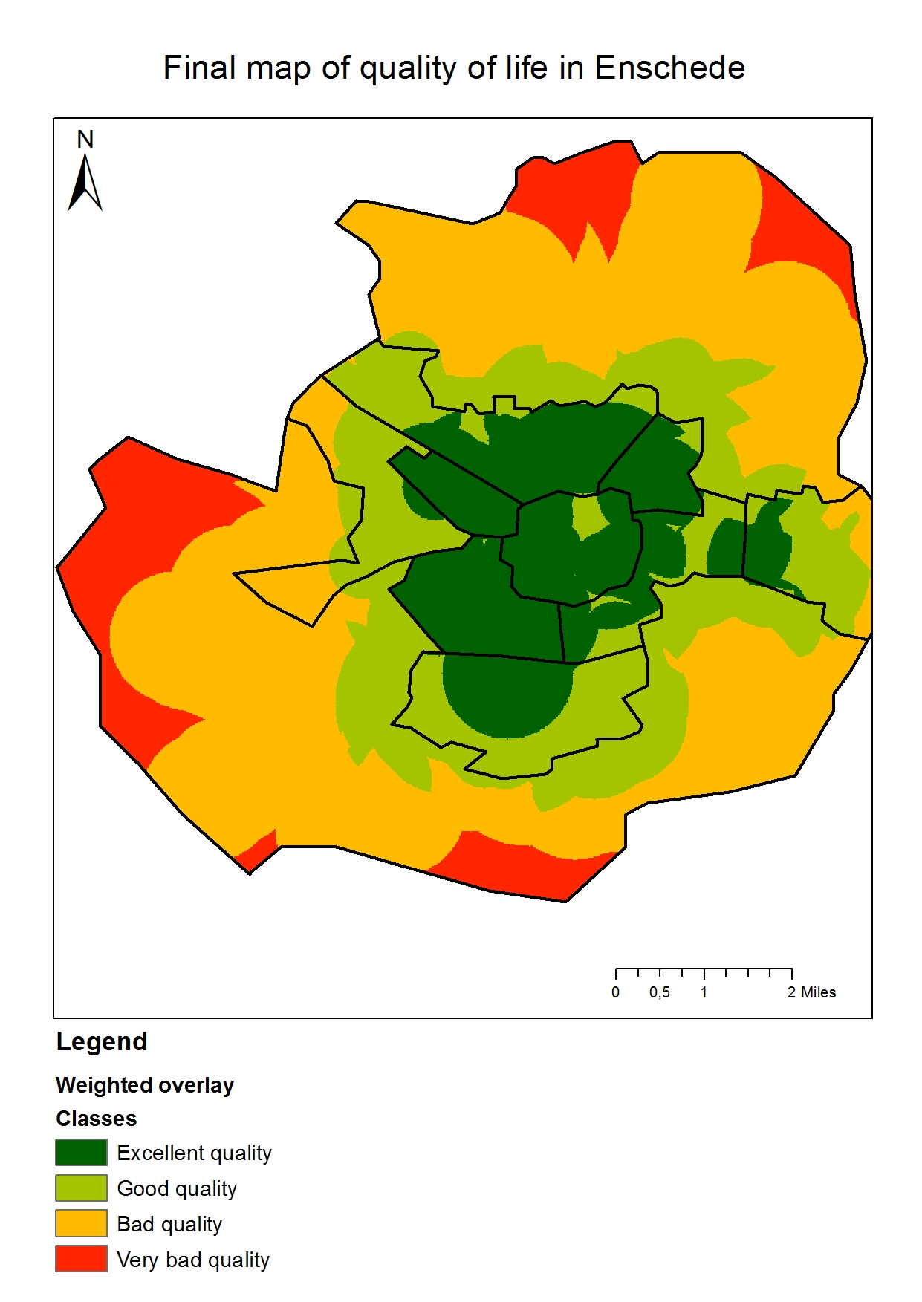
First final map.
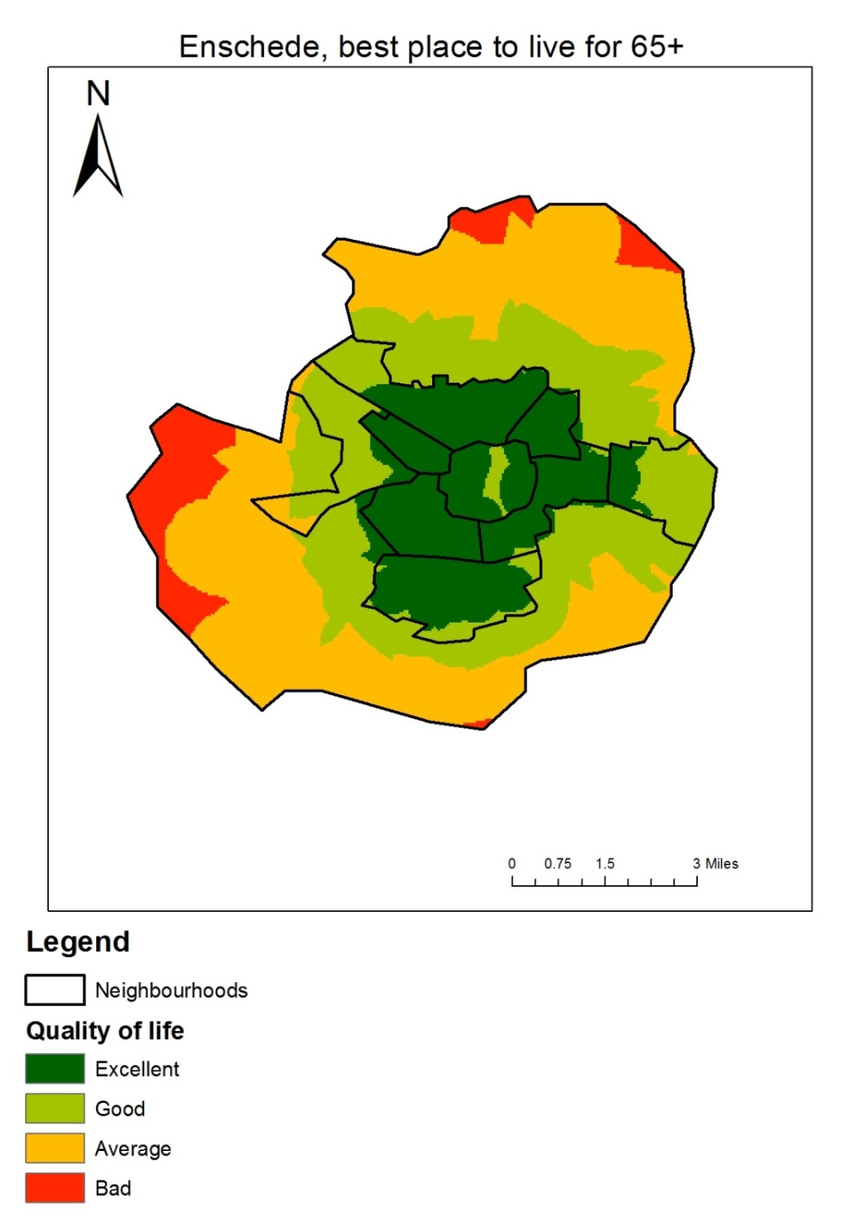

Second final map.
The first thing we can conclude from this map is that the center is the best place to live for someone of 65 years or older. This is because there are some important facilities in the center of Enschede. Most of the GP’s, shops and bus stops are located here. Because of the good connection by bus with the surrounding neighborhoods, is the quality in the surrounding neighborhoods also excellent. But the further away from the center, the further away you are from facilities like shopping centers or GP’s. This is influences the quality of life.
Another reason why the neighboring areas have a high quality of life is because of the density. Because the density is too high in the center and too low in the rural areas, the neighborhoods near the center scored very high.
As third, you can also see a little ‘gap’ in the center of Enschede. This gap is caused by the lack of nature area’s in that area. The building density is very high in the center and there is less place for parks, gardens or some kind of recreational water areas. This isn’t good for the quality of life. So an advice will be to create more nature areas in the center.
Last, the neighborhoods in the rural areas have a very bad quality of life. This is for a big part, caused by the lack of facilities. There living not a lot of people so it’s from an economic aspect not possible to open a GP or a shop there.

Discussion

We’ve learned a lot from this case study and our skills with GIS have definitely improved, but there were also some problems.
The biggest problem for us was that almost all of the data was in Dutch. The names and legends had to be translated several times. This was a very time-consuming activity and this is one of the main reasons we don’t have a lot of input.
Another point of discussion is the amount of classes we used for reclassifying. We reclassified distances, densities and percentages into four classes. A better option would have a been a final map with five classes. So we make a more clear distinction.

